SMART SOLUTION FOR RAILWAYS

TEAM ID:PNT2022TMID35794

SPRINT-4:WEATHER AND LOCATION:

MIT APP INVENTOR:

BACK-END SCREENSHOTS:

LOCATION:
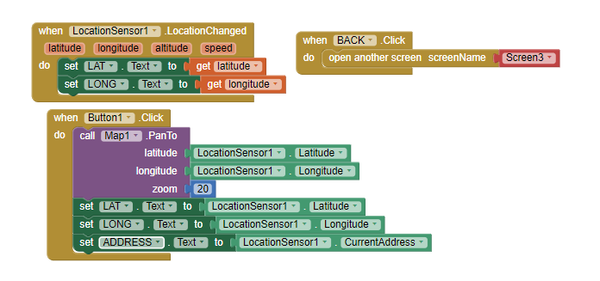

WEATHER:
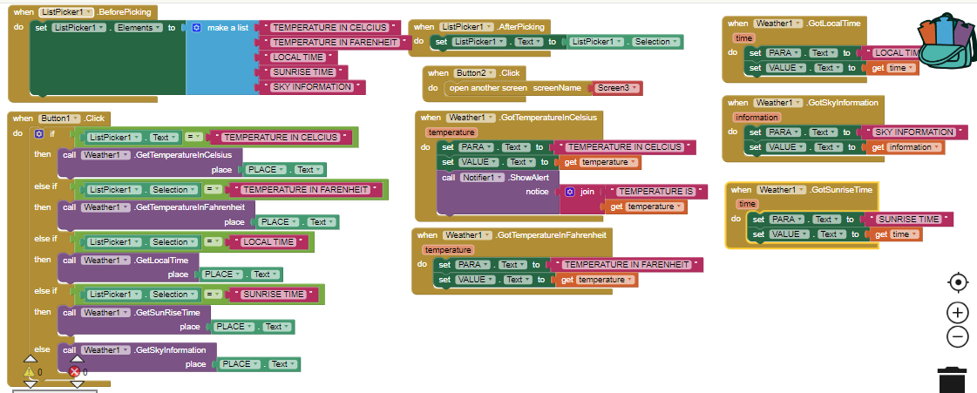

FRONT-END SCREENSHOTS:

LOCATION:
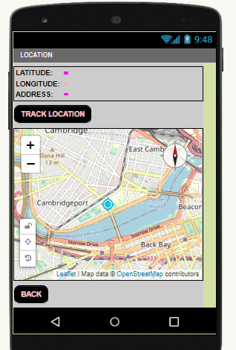

WEATHER:
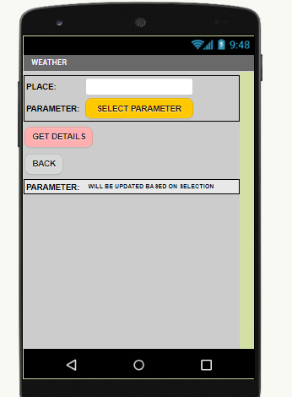

EXTENSIONS USED:

